Name:Levei Arul Bharathi J
Reg No:192424165
Date:19-01-2026
Course Code:DSA0412
16. Scenario:
You are working on a project that involves analyzing customer reviews for a product. You have a dataset containing customer reviews, and your task is to develop a Python program that calculates the frequency distribution of words in the reviews.
Question:
Develop a Python program to calculate the frequency distribution of words in the
customer reviews dataset?
Code:
reviews = [
"This product is very good",
"The quality of the product is excellent",
"Very good quality and good price",
"Product quality is good"
]
import string
text = " ".join(reviews)
text = text.lower()
for char in string.punctuation:
text = text.replace(char, "")
words = text.split()
word_frequency = {}
for word in words:
if word in word_frequency:
word_frequency[word] += 1
else:
word_frequency[word] = 1
print("Word Frequency Distribution:")
for word, count in word_frequency.items():
print(word, ":", count)
Output:

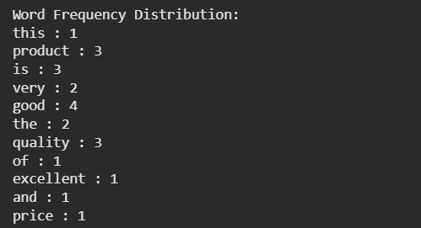
17. Scenario:
You are a data analyst working for a marketing research company. Your team has collected a large dataset containing customer feedback from various social media platforms. The dataset consists of thousands of text entries, and your task is to develop a Python program to analyze the frequency distribution of words in this dataset. Your program should be able to perform
the following tasks:
- Load the dataset from a CSV file (data.csv) containing a single column named "feedback"
- with each row representing a customer comment.
- Preprocess the text data by removing punctuation, converting all text to lowercase, and
- eliminating any stop words (common words like "the," "and," "is," etc. that don't carry
- significant meaning).
- Calculate the frequency distribution of words in the preprocessed dataset.
- Display the top N most frequent words and their corresponding frequencies, where N is
- provided as user input.
- Plot a bar graph to visualize the top N most frequent words and their frequencies.
- Question: Create a Python program that fulfills these requirements and helps your team gain
- insights from the customer feedback data.
Code for dataset:
import pandas as pd
feedback_data = pd.DataFrame({
"feedback": [
"This product is very good and useful",
"The service is excellent and the quality is good",
"Very bad experience and poor service",
"Good quality product and good service",
"Average product but good price"
]
})
feedback_data.to_csv("data.csv", index=False)
print("data.csv file created successfully")
Core code:
import pandas as pd
import matplotlib.pyplot as plt
import string
from collections import Counter
data = pd.read_csv("data.csv")
stop_words = {
"the", "and", "is", "in", "to", "of", "a", "an", "for", "on",
"with", "this", "that", "it", "as", "was", "are", "be", "by"
}
text = " ".join(data["feedback"].astype(str))

text = text.lower()
for char in string.punctuation:
text = text.replace(char, "")
words = text.split()
filtered_words = [word for word in words if word not in stop_words]
word_freq = Counter(filtered_words)
N = int(input("Enter number of top frequent words to display: "))
top_words = word_freq.most_common(N)
print("\nTop", N, "most frequent words:")
for word, freq in top_words:
print(word, ":", freq)
words, frequencies = zip(*top_words)
plt.bar(words, frequencies)
plt.xlabel("Words")
plt.ylabel("Frequency")
plt.title("Top " + str(N) + " Frequent Words in Customer Feedback")
plt.xticks(rotation=45)
plt.show()
Output:
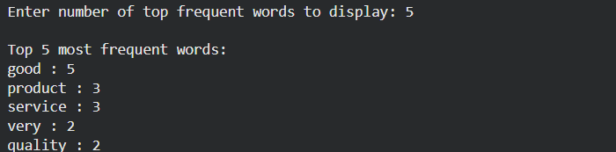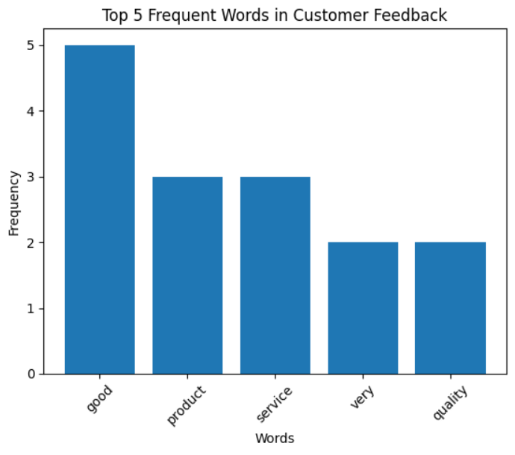
18. Suppose a hospital tested the age and body fat data for 18 randomly selected adults with the
following result.
Question:
• Calculate the mean, median and standard deviation of age and %fat using Pandas.
• Draw the boxplots for age and %fat.
• Draw a scatter plot and a q-q plot based on these two variables
Code:
import pandas as pd
import matplotlib.pyplot as plt
import scipy.stats as stats
data = pd.DataFrame({
"Age": [23, 25, 28, 30, 32, 35, 37, 40, 42, 45, 47, 50, 52, 55, 57, 60, 62, 65],
"Body_Fat": [18, 20, 22, 24, 25, 27, 28, 30, 32, 34, 35, 37, 38, 40, 42, 43, 45, 47]
})
print(data.agg(["mean", "median", "std"]))
data.boxplot(column=["Age", "Body_Fat"])
plt.show()
plt.scatter(data["Age"], data["Body_Fat"])
plt.xlabel("Age")
plt.ylabel("Body Fat (%)")
plt.show()
stats.probplot(data["Age"], plot=plt)
plt.show()
stats.probplot(data["Body_Fat"], plot=plt)
plt.show()
Output:
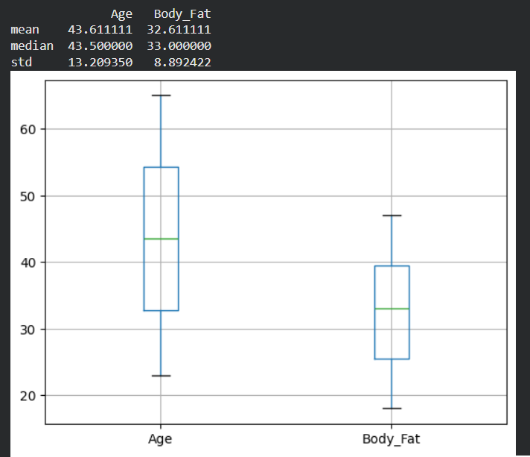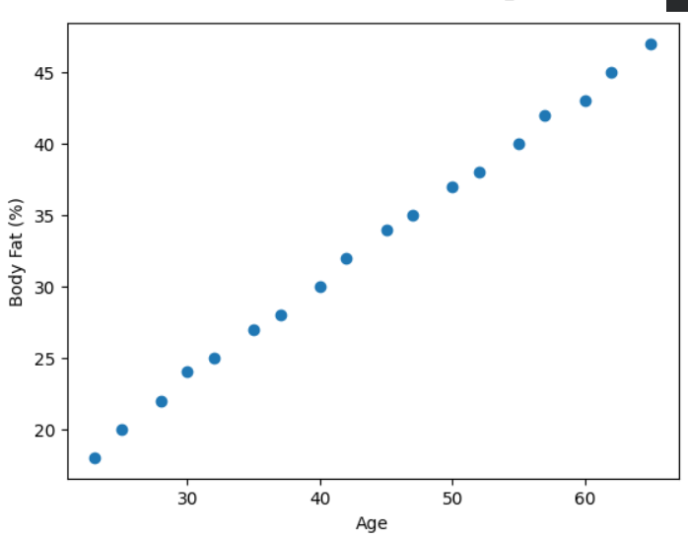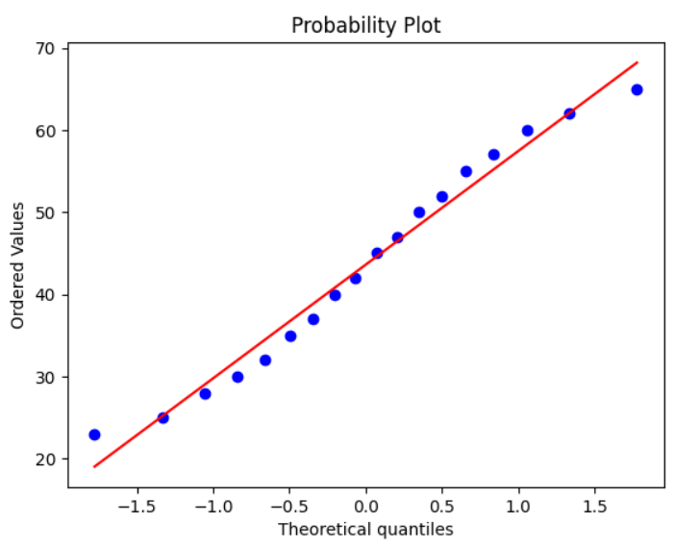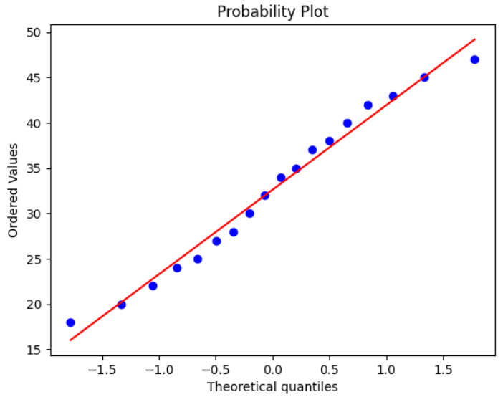

19. Scenario:
You are a medical researcher investigating the effectiveness of a new drug in reducing blood pressure. You conduct a clinical trial with a sample of 50 patients who were randomly assigned to receive either the new drug or a placebo. After measuring their blood pressure levels at the end of the trial, you obtain the data for both groups. Now, you want to determine the confidence intervals for the mean reduction in blood pressure for both the drug and placebo groups.
Question:
"What is the 95% confidence interval for the mean reduction in blood pressure for patients who received the new drug? Also, what is the 95% confidence interval for the mean reduction in blood pressure for patients who received the placebo?
Code:
import numpy as np
from scipy import stats
np.random.seed(0)
drug = np.random.normal(12, 4, 50)
placebo = np.random.normal(5, 3, 50)
def confidence_interval(data):
mean = np.mean(data)
sem = stats.sem(data)
return stats.t.interval(0.95, len(data)-1, mean, sem)
print("Drug CI:", confidence_interval(drug))
print("Placebo CI:", confidence_interval(placebo))
Output:

40. Scenario: You are a data analyst working for a sports analytics company. The company has collected data on various soccer players, including their names, ages, positions, number of goals scored, and weekly salaries. Create dataset on your own and store in a CSV file.
Question:
Develop a Python program to read the data from the CSV file into a pandas data frame, to find the top 5 players with the highest number of goals scored and the top 5 players with the highest salaries. Also calculate the average age of players and display the names of players who are.above the average age and visualize the distribution of players based on their positions using a bar chart.
Code:
design_A = np.random.normal(0.12, 0.02, 100)
design_B = np.random.normal(0.15, 0.02, 100)
t_stat, p_value = stats.ttest_ind(design_A, design_B)
print("T-statistic:", t_stat)
print("P-value:", p_value)
if p_value < 0.05:
print("Statistically significant difference")
else:
print("No statistically significant difference")
Output:
